Lab 2: Computer Networks: Vedanth Mapakshi: 20374094

I first downloaded the Microsoft windows server 2016 iso file and created a bootable usb by using WUDT. Then, I installed the image with desktop experience on virtual box in bridged mode. After that, I installed virtual box guest additions for my virtual windows server 2016. After that, I created a folder on my host machine, put a file in it and reconfigured the folders sharing properties by giving permissions to everyone on my network followed by turning off my PC's firewall and making it discoverable to other computers on my network. I was then able to view the shared folder on clicking the host shared folder and giving the host credentials. Next moving on to my server. I created a folder and put a file in it. Then I entered the windows powershell and installed file and storage services / Iscsi onto server manager. Then I created another folder with a file in my virtual windows server and through file and storage services on server manager, I created a new shared and set a path to my created folder. And followed the steps on the wizards bascially doing an smb share and giving permissions to my host computer. Therefore I was able to view the shared folders and their files from the host and virtual windows server.

We need professional version of windows because unlike other versions they allow us to host a remote desktop server.

To connect two computers without using a switch, we will need a crossover cable and two network cards. We plug in network card each to computer and then connect the network cable to both computers network card. Then, we can install the network cards on each computer and configure the IP address and subnet mask appropriately.

1. Installation of Windows Server 2016:

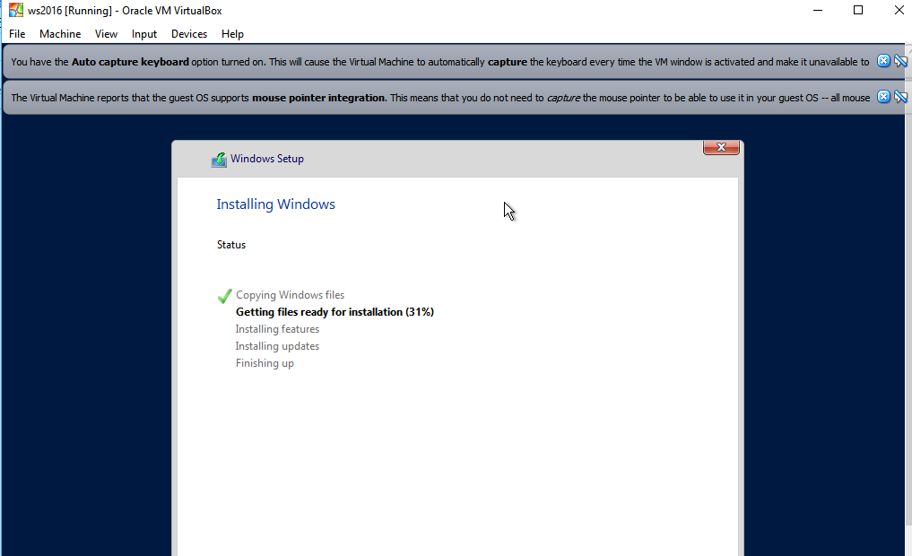

1. Installation of guest additions:

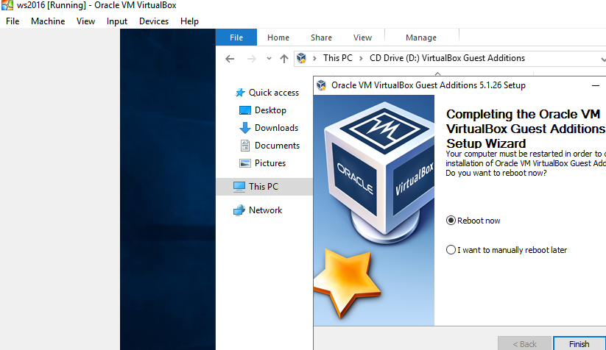

1. Virtual machine connected to the internet:

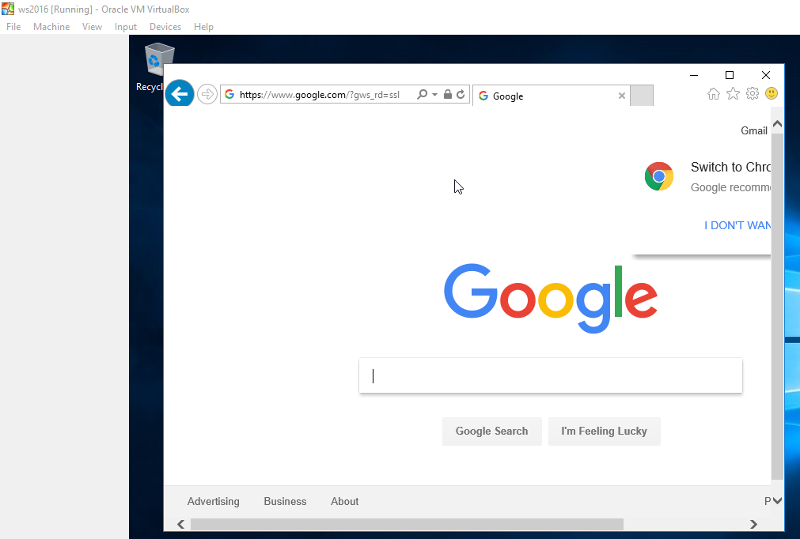

1. Host Shared Folder on Virtual machine

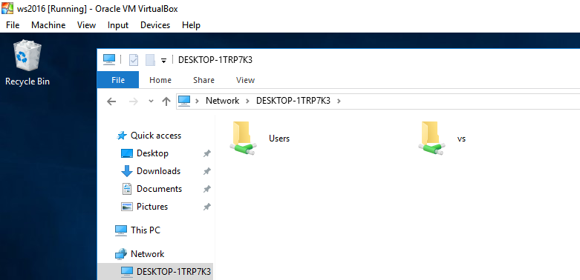

1. Virtual machine shared folder on host:

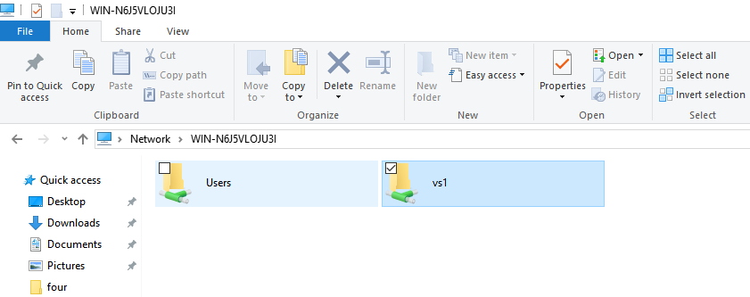

Opened folder to view file inside:

